

**Capstone Project Final Report**

**Project title: Social Fashion Network (SOFA)**

**Hanoi, May 6th, 2021**

**Table of Contents**

**No table of contents entries found.**

Chapter 1: **Introduction**

1. **Purpose**

This chapter provides an overview of the project including background information, a literature review of the existing system and raising a proposal for ideas of improvement.

1. **Project Information**

* Project name: **SOFA – Fashion Social Network**
* Project code: **SOFA**
* Project group name: **SWP490_G22**
* Product type: **Mobile Application – Android**

1. **Project Team**

### Supervisor

|  |  |  |  |  |
| --- | --- | --- | --- | --- |
|  | **Full name** | **Phone** | **E-mail** | **Title** |
| Supervisor | Phạm Ngọc Hà | 0988623000 | [hapn10](mailto:hapn10)@fpt.edu.vn | Lecturer |

### Team Members

|  |  |  |  |  |  |
| --- | --- | --- | --- | --- | --- |
| **No.** | **Full name** | **Student ID** | **Phone** | **E-mail** | **Role** |
| 1 | Lê Thiện Văn | HE130820 | 0375956599 | vanLTHE130820@fpt.edu.vn | Leader |
| 2 | Nguyễn Huy Hoàng | HE130395 | 0355517865 | hoangNHHE130395@fpt.edu.vn | Document Lead |
| 3 | Hà Việt Dũng | HE130952 | 0942561863 | dungHVHE130952@fpt.edu.vn | Member |
| 4 | Mai Văn Viên | SE05783 | 0969614666 | vienMVSE05783@fpt.edu.vn | Test Lead |
| 5 | Nguyễn Thanh Tùng | SE05590 | 0344261997 | tungNTSE05590@fpt.edu.vn | Member |

1. **Background**

Today, in a developing age, living conditions are getting higher and higher. Eat well and dress well instead of eating fully and dressing warmly. Fashion is almost indispensable for every person. Fashion tells almost everything about a person, helps a person more beautiful and makes someone confident. But not all people know how to choose clothes which are suitable for themselves. To resolve this problem, we develop a system that allows users to share their dress styles and suggest them to other users. So, thanks to this system every people could choose suitable clothes and dress style.

1. **Literature review of existing system**
   1. Dress As

The fashion social network for women. This app can be downloaded on Google Play.

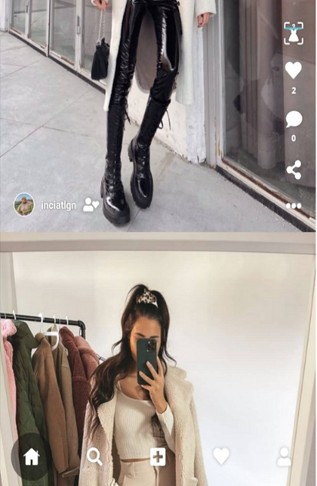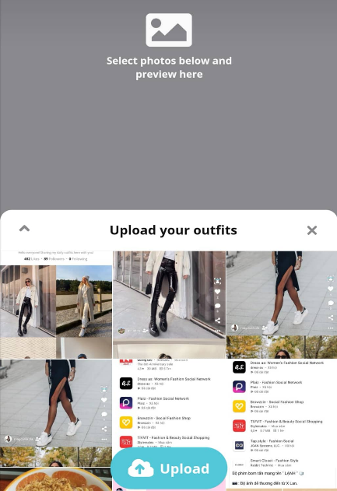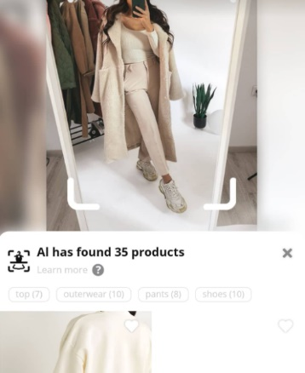

|  |  |  |
| --- | --- | --- |
| **Advantages** | **Disadvantages** | **Compare with SOFA** |
| GUI simple, modern | Just for women | For everybody |
| Easy to share a personal image | Simply an app to share images and search for related products, with little social network direction | A social network, allow interaction between users more than the existed app (Can chat, add friend, comment…) |
| Can search for similar products by image | Don’t allow write the caption for image, don’t allow share post | Allow write the caption, interaction, comment, share |
|  | Don’t have feature fashion trending | Have feature fashion trending |
|  | Don’t have feature suggest style and clothes for user | Based on user's data along with fashion style then suggest style and clothes for post who have similar data |
|  | There isn't feature posts featured based on interactions, posts of KOL | Have feature posts featured based on interactions, posts of KOL |
|  | There isn’t suggest where a user can buy the product. Search product restricted products on asos.com website | Suggest where a user can buy the product. Not restricted search product. |
|  | User are those who want to share pictures of fashion, do not have shop features | Have feature for seller and shop |

* 1. Fashion Tap

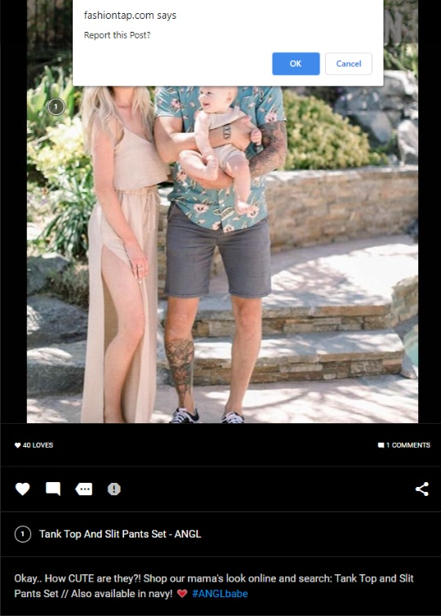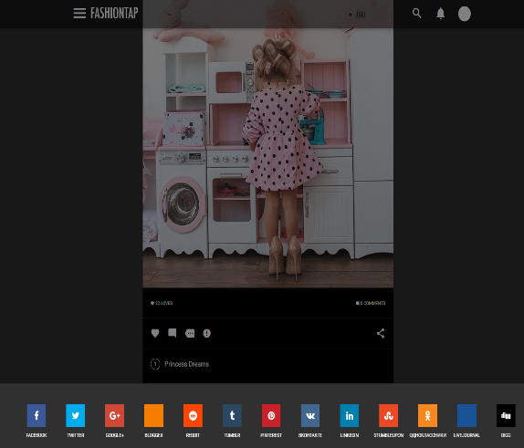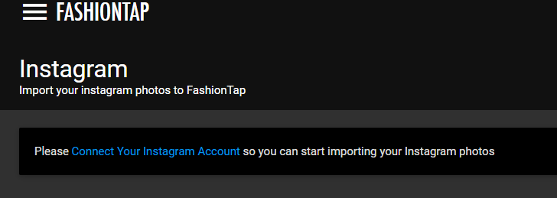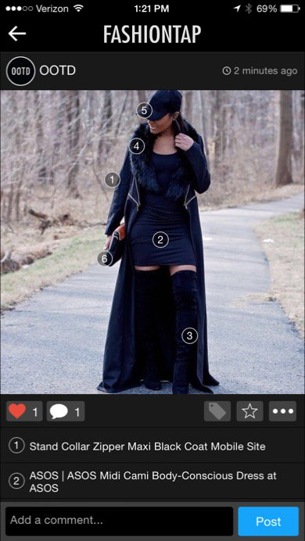

|  |  |  |
| --- | --- | --- |
| **Advantages** | **Disadvantages** | **Compare with SOFA** |
| Allows users to insert links on each item in the photo leading to the place of sale | The system still has many errors. For example, the image cropping feature after upload is still faulty |  |
| Can import photos from Instagram to FashionTap | Simply an app to share images, with little social network direction | The social network allows interaction between users more than existed app (Can chat, add friend, comment…) |
| After uploading photos, you can use the system's tools to edit the photos before posting | Don’t have feature fashion trending | Have feature fashion trending |
| Allows users to share post to other social networking | Don’t have feature suggest style and clothes for user | Based on user's data along with fashion style then suggest style and clothes for other users who have similar data |
| Can report post with bad content | There isn't feature posts featured based on interactions, posts of KOL | Have feature posts featured based on interactions, posts of KOL |
| Can review all product about fashion include clothes, cosmetics, accessories fashion | Don’t have feature rating for the post | User can rate post that show the quality of the post |
| Have feature ask and answer |  |  |

## Smart Fashion

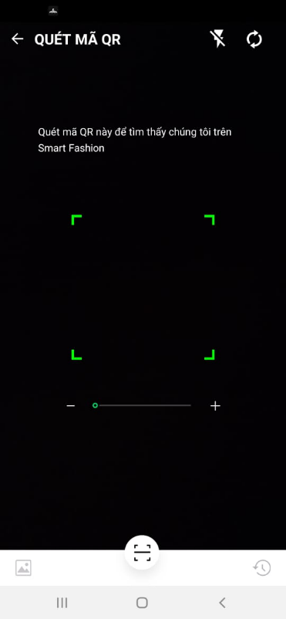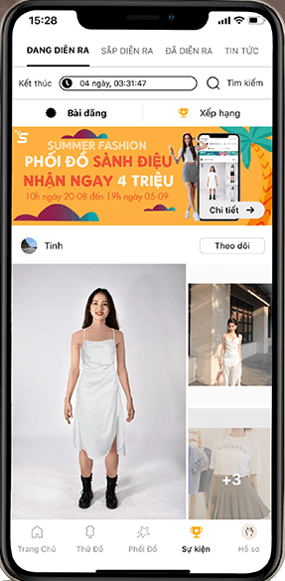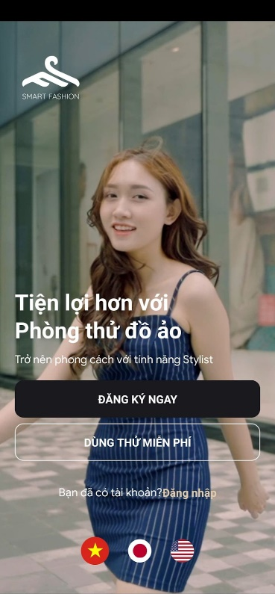

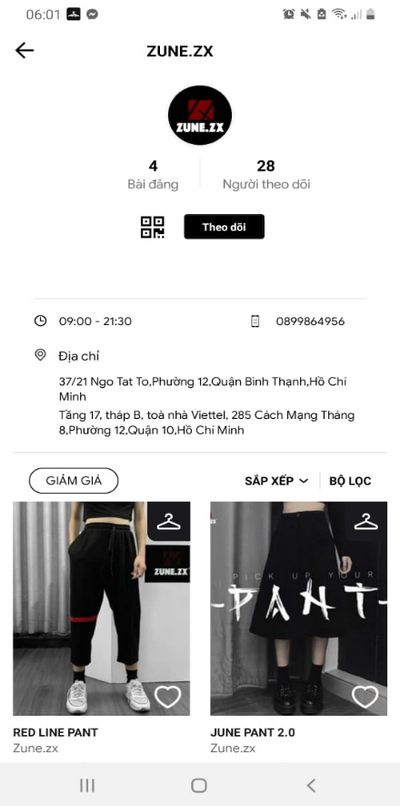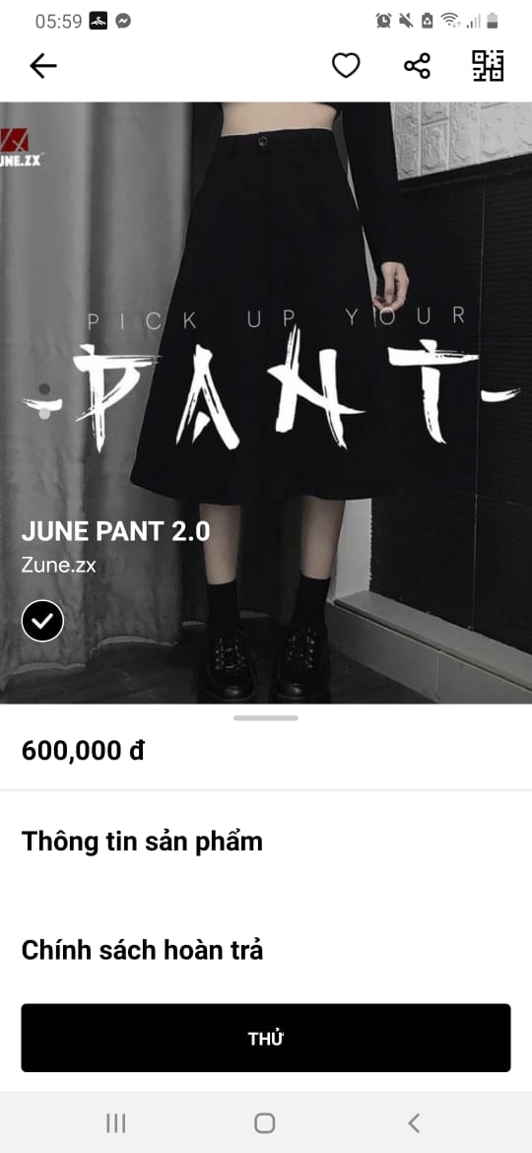

|  |  |  |
| --- | --- | --- |
| **Advantages** | **Disadvantages** | **Compare with SOFA** |
| User can try clothes on a virtual model (Use deep-learning to simulate clothing and try on a virtual model) | focus on features buy, trial and sell, so it does not attract a large number of users. | User can post, share their image, chat and add friend with other people |
| Can search product by scan QR code | Don't have interaction between users | Social network, allow interaction between users more than existed app (Can chat, add friend, comment…) |
| Can create event (make user interest app) | Don’t have feature fashion trending | Have feature fashion trending |
| Have feature for seller and shop | Don’t have feature suggest style and clothes for user | Based on user's data along with fashion style then suggest style and clothes for other users who have similar data |
| User can save the product that they like | The system still has many errors. |  |

1. **Business Opportunity**

Today, the problem about choose fashion style and clothes is hot, besides that linking between shop and customer is very important. So, it's a good opportunity for fashion social networking and suggests fashion system to develop.

However, User's need and the shop's need are not similar. Shop want to customer know about their product. People want to know how to choose style and clothes for themselves and where they can buy that product. So, SOFA will try to solve the problem by the way that allows users to share personal fashion style, suggest for user the fashion style that suitable for them and hint user shops where they can buy that product.

SOFA will help user choose clothes and find clothes, help customers know about the product of shops.

1. **Software Product Vision**

With the applying recommendation system and deep-learning API to suggest clothes and fashion style for user. We want to we aim to optimize the operation of system. We develop system with backend is a restful API, frontend for the manager is a website and frontend for user is android app. Mobile app help user feel conveniently and easy to use (for example, user can take a picture, upload picture every time, everywhere). Backend restful API will help us develop frontend for user on other platforms like website, android app...

1. **System Functions**